**Pre-test Pokémon**

**Purpose:**

Chose neutral and unfamiliar Pokémon characters to use as stimuli in a replication project (i.e., a replication of the surveillance task used by Olson & Fazio, 2001)

**Procedure:**

60 pictures of Pokémon (image + name) were presented in a random order. The 60 Pokémon were chosen from generations 4-7 to decrease the chances that they will be familiar to participants (see images below).

Instructions in the beginning:

*Welcome to the experiment! Thank you for taking part.*

*In this task, we are going to present you pictures of different creatures.*

*Please indicate how positive or negative you consider the creature to be, and how familiar are you with it.*

Ratings

Participants rated each Pokémon character on two scales:

1. Please rate how positive or negative this creature is using the scale below

SCALE: -4 = very negative, 0 = Neutral, 4 = very positive

2. Please rate how familiar are you with this creature is using the scale below

SCALE: 0 = Not Familiar at all, 8 = Very Familiar

**Participants:**

The pretest was run on Prolific Academic (https://prolific.ac/). We limited the study to participants from the US and UK, and between the ages 18-26 (age range that is similar to the age of participants that will participate in the replication). For 80% power to detect a small effect (d=0.2) we needed to collect data from 156 participants. Data from one participant was not recoded.

**Planed Analysis:**

We planned to computed mean liking score and mean familiarity score for each character.

Based on participants ratings, we planned to choose 9 characters that were rated close to 0 (neutral) on the liking scale, and below 4 in the familiarity scale. Two of these characters will be used as CSs, 5 as targets and 2 as fillers in the replication. We planned to verify with t-test and Bayes-Factor analysis that:

1. Mean liking scores for each chosen characters does not differ from 0
2. Mean familiarity scores for each chosen characters is below 4
3. The liking scores and familiarity scores of the two selected CSs do not differ from one another.

I**mages:**

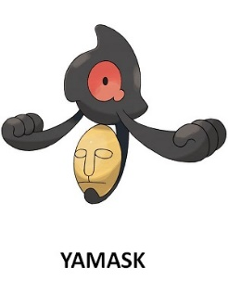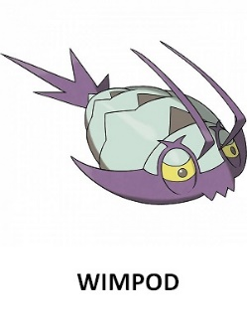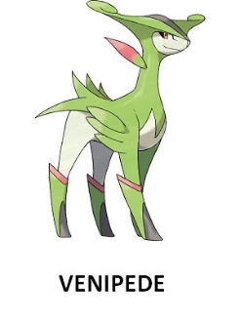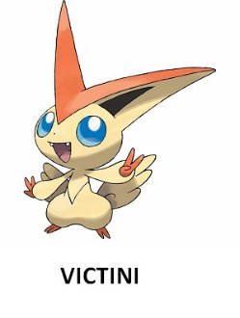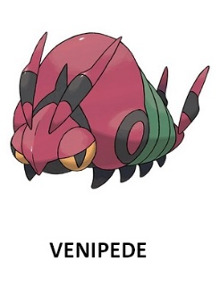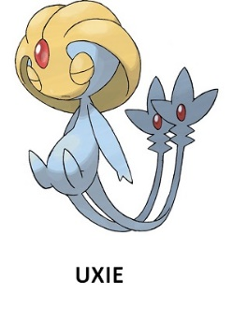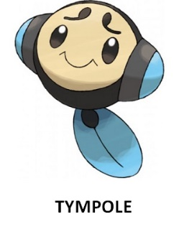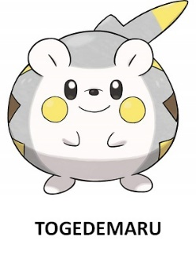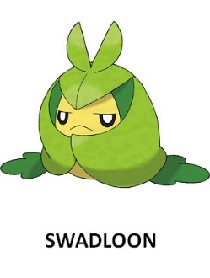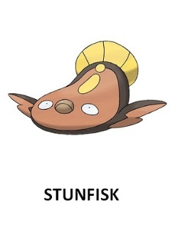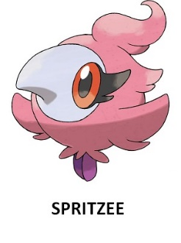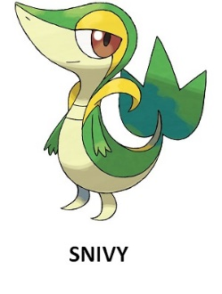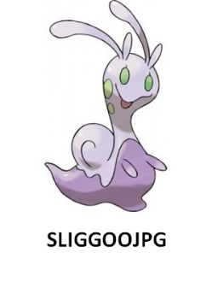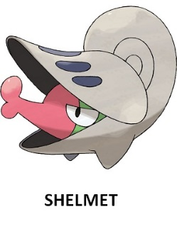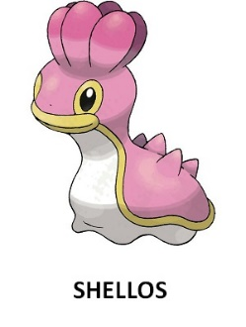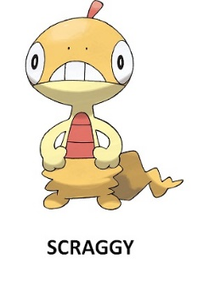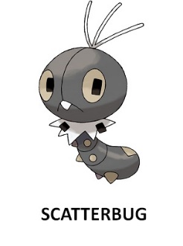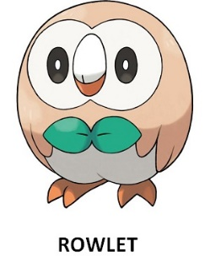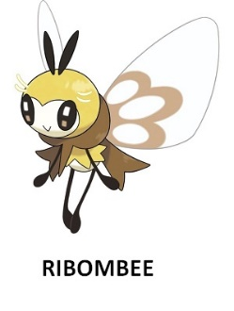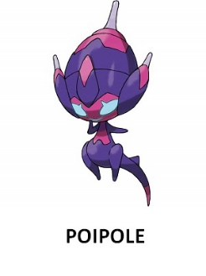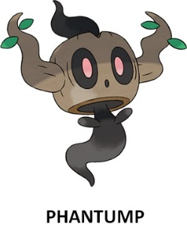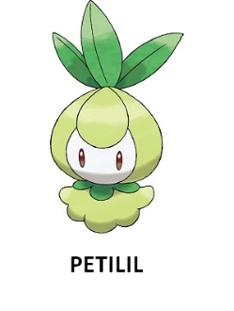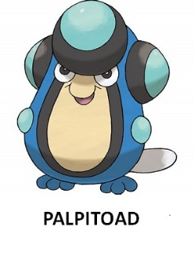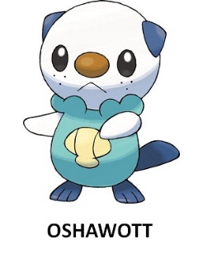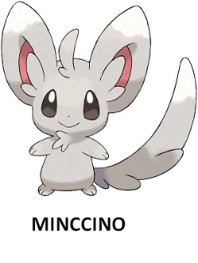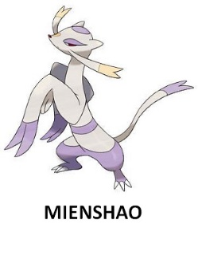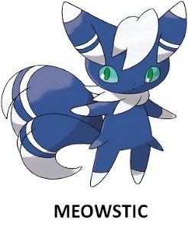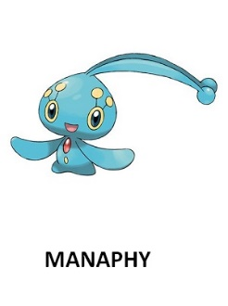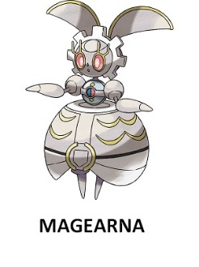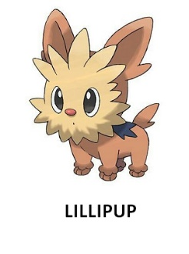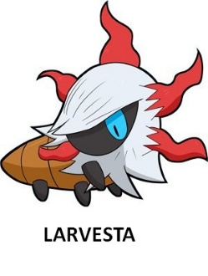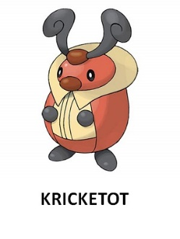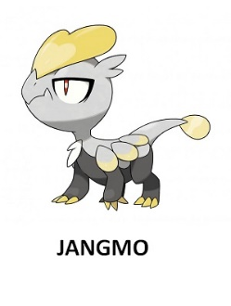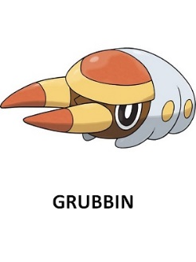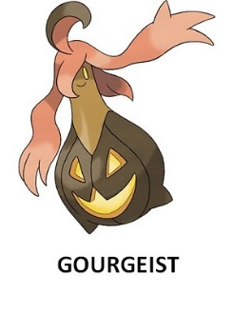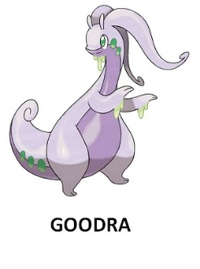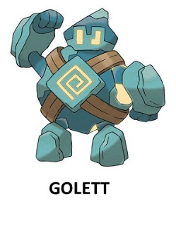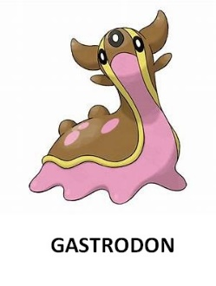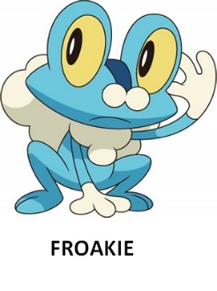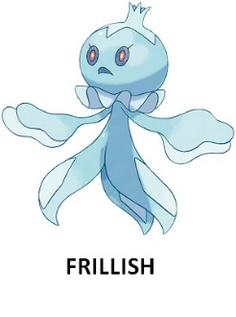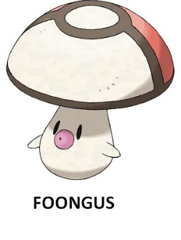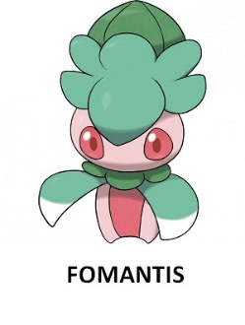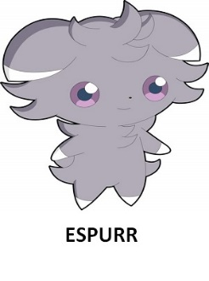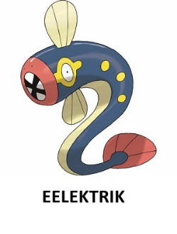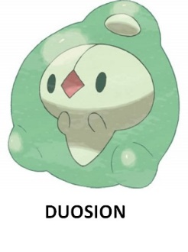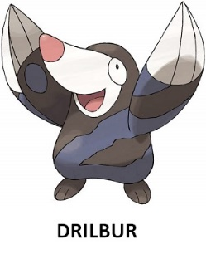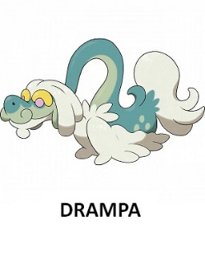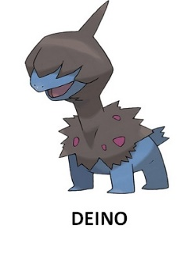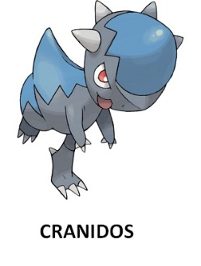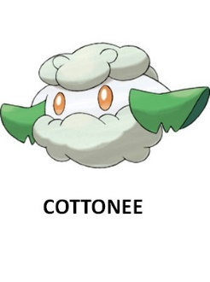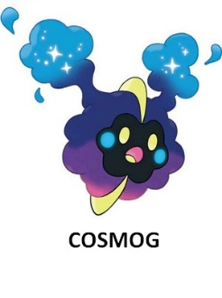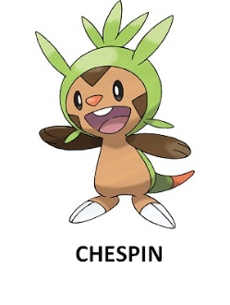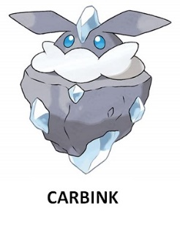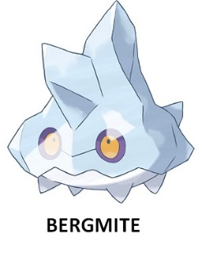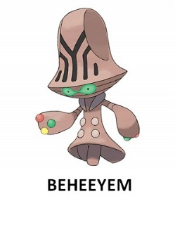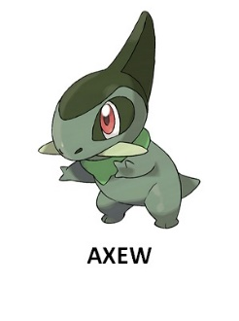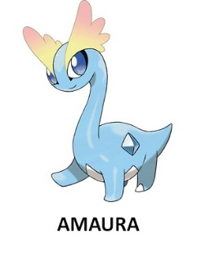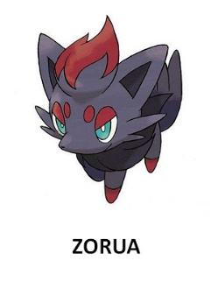

**Results**

155 participants completed the pretest (Mage = 22.95, SD = 3.25, 49% women)

|  |  |  |  |  |  |  |  |
| --- | --- | --- | --- | --- | --- | --- | --- |
| **name** | **mean_liking** | **sd_liking** | **like_d.es** | **mean_fami** | **sd_fami** | **fmi_d.es** | **n** |
| Magearna | -0.025 | 2.224 | 0.011 | 1.406 | 2.340 | 0.011 | 155 |
| Shelmet | -0.051 | 1.973 | 0.026 | 1.896 | 2.658 | 0.026 | 155 |
| Scraggy | -0.064 | 1.932 | 0.033 | 2.458 | 3.052 | 0.033 | 155 |
| Palpitoad | 0.187 | 2.220 | 0.084 | 1.664 | 2.606 | 0.084 | 155 |
| Bergmite | 0.167 | 1.840 | 0.091 | 1.541 | 2.308 | 0.091 | 155 |
| Golett | 0.251 | 2.145 | 0.117 | 1.612 | 2.466 | 0.117 | 155 |
| Grubbin | -0.251 | 1.905 | 0.132 | 1.567 | 2.478 | 0.132 | 155 |
| Cranidos | 0.335 | 2.282 | 0.146 | 2.483 | 3.163 | 0.146 | 155 |
| Swadloon | 0.290 | 1.879 | 0.154 | 1.806 | 2.655 | 0.154 | 155 |
| Scatterbug | -0.290 | 1.833 | 0.158 | 1.729 | 2.596 | 0.158 | 155 |
| Frillish | 0.361 | 2.128 | 0.169 | 1.716 | 2.570 | 0.169 | 155 |
| Stunfisk | -0.329 | 1.927 | 0.170 | 1.864 | 2.706 | 0.170 | 155 |
| Zorua | 0.387 | 2.124 | 0.182 | 2.290 | 3.002 | 0.182 | 155 |
| Phantump | -0.503 | 2.437 | 0.206 | 1.612 | 2.561 | 0.206 | 155 |
| Sliggoo | 0.432 | 2.003 | 0.215 | 1.716 | 2.593 | 0.215 | 155 |
| Poipole | -0.477 | 2.117 | 0.225 | 1.277 | 2.257 | 0.225 | 155 |
| Gourgeist | -0.574 | 2.235 | 0.256 | 1.670 | 2.494 | 0.256 | 155 |
| Jangmo | 0.503 | 1.785 | 0.281 | 1.503 | 2.391 | 0.281 | 155 |
| Wimpod | -0.664 | 2.052 | 0.323 | 1.464 | 2.361 | 0.323 | 155 |
| Carbink | 0.6 | 1.836 | 0.326 | 1.922 | 2.693 | 0.326 | 155 |
| Kricketot | 0.690 | 1.922 | 0.359 | 2.406 | 3.153 | 0.359 | 155 |
| Drampa | 0.722 | 1.985 | 0.363 | 1.632 | 2.520 | 0.363 | 155 |
| Cosmog | 0.858 | 2.305 | 0.372 | 1.858 | 2.780 | 0.372 | 155 |
| Gastrodon | 0.716 | 1.850 | 0.386 | 2.354 | 2.940 | 0.386 | 155 |
| Larvesta | -0.845 | 2.156 | 0.391 | 1.490 | 2.431 | 0.391 | 155 |
| Deino | 0.806 | 2.048 | 0.393 | 1.929 | 2.735 | 0.393 | 155 |
| Cottonee | 0.845 | 1.964 | 0.430 | 2.064 | 2.764 | 0.430 | 155 |
| Yamask | -0.909 | 2.090 | 0.435 | 1.696 | 2.663 | 0.435 | 155 |
| Goomy | 0.916 | 2.085 | 0.439 | 1.948 | 2.701 | 0.439 | 155 |
| Beheeyem | -1 | 2.162 | 0.462 | 1.580 | 2.555 | 0.462 | 155 |
| Foongus | 0.967 | 1.938 | 0.499 | 1.987 | 2.640 | 0.499 | 155 |
| Axew | 0.948 | 1.899 | 0.499 | 2.458 | 2.959 | 0.499 | 155 |
| Spritzee | 0.870 | 1.719 | 0.506 | 1.509 | 2.347 | 0.506 | 155 |
| Mienshao | 0.961 | 1.808 | 0.531 | 1.929 | 2.701 | 0.531 | 155 |
| Goodra | 1.083 | 2.006 | 0.540 | 1.987 | 2.876 | 0.540 | 155 |
| Fomantis | 0.954 | 1.766 | 0.540 | 1.593 | 2.258 | 0.540 | 155 |
| Venipede | -1.296 | 2.341 | 0.553 | 1.961 | 2.828 | 0.553 | 155 |
| Eelektrik | -1.251 | 2.220 | 0.563 | 1.748 | 2.637 | 0.563 | 155 |
| Uxie | 1.058 | 1.869 | 0.565 | 2.477 | 3.146 | 0.565 | 155 |
| Froakie | 1.109 | 1.915 | 0.579 | 2.806 | 3.168 | 0.579 | 155 |
| Tympole | 1.148 | 1.895 | 0.605 | 1.761 | 2.568 | 0.605 | 155 |
| Duosion | 1.161 | 1.849 | 0.627 | 1.690 | 2.610 | 0.627 | 155 |
| Snivy | 1.503 | 1.870 | 0.803 | 3.122 | 3.283 | 0.803 | 155 |
| Oshawott | 1.541 | 1.855 | 0.830 | 2.851 | 3.278 | 0.830 | 155 |
| Drilbur | 1.658 | 1.877 | 0.883 | 1.954 | 2.687 | 0.883 | 155 |
| Shellos | 1.612 | 1.777 | 0.907 | 2.419 | 3.034 | 0.907 | 155 |
| Virizion | 1.606 | 1.763 | 0.910 | 2.116 | 2.828 | 0.910 | 155 |
| Inkay | 1.606 | 1.756 | 0.914 | 1.954 | 2.728 | 0.914 | 155 |
| Espurr | 1.683 | 1.753 | 0.960 | 2.064 | 2.861 | 0.960 | 155 |
| Victini | 1.767 | 1.826 | 0.967 | 2.432 | 3.010 | 0.967 | 155 |
| Meowstic | 1.670 | 1.709 | 0.977 | 1.961 | 2.620 | 0.977 | 155 |
| Ribombee | 1.722 | 1.737 | 0.991 | 1.703 | 2.481 | 0.991 | 155 |
| Petilil | 1.793 | 1.610 | 1.113 | 2.219 | 2.759 | 1.113 | 155 |
| Amaura | 2.083 | 1.724 | 1.208 | 1.683 | 2.547 | 1.208 | 155 |
| Togedemaru | 2.193 | 1.802 | 1.217 | 1.845 | 2.699 | 1.217 | 155 |
| Chespin | 2.032 | 1.633 | 1.244 | 2.696 | 3.199 | 1.244 | 155 |
| Rowlet | 2.406 | 1.650 | 1.458 | 3.148 | 3.290 | 1.458 | 155 |
| Minccino | 2.483 | 1.676 | 1.481 | 2.393 | 2.970 | 1.481 | 155 |
| Lillipup | 2.432 | 1.579 | 1.540 | 2.812 | 3.046 | 1.540 | 155 |
| Manaphy | 2.470 | 1.588 | 1.555 | 2.903 | 3.282 | 1.555 | 155 |

The nine most neutral:

Liking: t-test is for difference from zero

Familiarity: t-test is for difference from 4

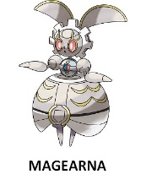

Liking: t(154) = -0.14, p = 0.883, d =-0.01, BF10 = 0.09, BF01 = 11.11

Familiarity: t(154) = -13.79, p < 0.001, d =-1.10, BF10 > 1000



Liking: t(154) = -0.32, p = 0.745, d =-0.02, BF10 = 0.094, BF01 =10.63

Familiarity: t(154) = -9.84, p < 0.001, d =-0.79, BF10 > 1000

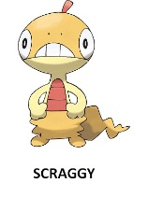

Liking: t(154) = -0.41, p = 0.678, d =-0.03, BF10 = 0.097, BF01 =10.30

Familiarity: t(154) = -6.28, p < 0.001, d =-0.50, BF10 > 1000

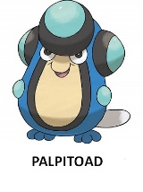

Liking: t(154) = 1.04, p = 0.295, d =0.08, BF10 = 0.153, BF01 =6.53

Familiarity: t(154) = -11.15, p < 0.001, d =-0.89, BF10 > 1000

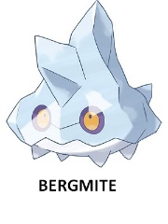

Liking: t(154) = 1.13, p = 0.258, d =0.09, BF10 = 0.168, BF01 = 5.95

Familiarity: t(154) = -13.25, p < 0.001, d =-1.06, BF10 > 1000

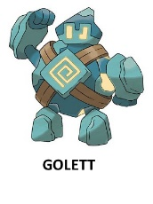

Liking: t(154) = 1.45, p = 0.146, d =0.11, BF10 = 0.253, BF01 = 3.95

Familiarity: t(154) = -12.01, p < 0.001, d =-0.96, BF10 > 1000

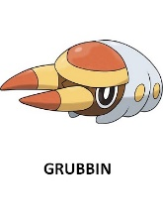

Liking: t(154) = -1.64, p = 0.102, d =-0.13, BF10 = 0.333, BF01 = 3.00

Familiarity: t(154) = -12.21, p < 0.001, d =-0.98, BF10 > 1000

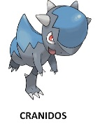

Liking: t(155) = 1.82, p = 0.069, d =0.14, BF10 = 0.455, BF01 = 2.19

Familiarity: t(154) = -5.96, p < 0.001, d =-0.47, BF10 > 1000

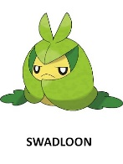

Liking: t(154) = 1.92, p = 0.056, d =0.15, BF10 = 0.538, BF01 = 1.85

Familiarity: t(154) = -10.28, p < 0.001, d =-0.82, BF10 > 1000

Choose CSs – I started to compare pairs of Pokémon starting from the most neutral in valence. The criteria were: no difference in valence or in familiarity (based on p-value > 0.05 from t-test and BF01 > 3). If a pair didn’t met these two criteria, I tested the next pair until the two criteria are met

**CSs will be Bergmit and Palpitoad**

Difference between them:

Liking: t(154) = 0.09, p= .920, d = 0.008, BF10 = 0.089, BF01 = 11.23

Familiarity: t(154) = 0.860, p= .391, d = 0.069, BF10 = 0.128, BF01 = 7.81

**Targets will be:** Grubbin, Magearna, Golett, Shelmet, Cranidos

**Fillers will be:** Scraggy, Swadloon

**Items for a future pretest (including the 20 most neutral Pokémon’s):**

* **We excluded stimuli too small in size**

